**Problem Statement:**

A health insurance company is seeking to enhance its understanding of operational performance by analyzing historical data related to policyholders, insurance policies, and claims. The goal is to identify key performance trends, improve customer segmentation, and make data-driven decisions for optimizing profitability and service quality.

Each dataset includes relevant fields such as:

**Policyholders:** policyholder_id, full_name, gender, date_of_birth, email, phone

**Policies:** policy_id, policyholder_id, policy_type, start_date, end_date, premium_amount, status

**Claims:** claim_id, policy_id, claim_date, claim_amount, claim_status, claim_type

**Approach:**

I queried data using SQL to understand patterns in profitability, customer segmentation, and claim performance. Key variables such as policy type, premium and claim amounts, claim status, and demographic attributes were analyzed.

**Question:**

1. Which policy type has the highest average claim amount?

SELECT

p.policy_type,

ROUND(AVG(c.claim_amount), 2) AS average_claim_amount

FROM policies p

JOIN claims c ON p.policy_id = c.policy_id

GROUP BY p.policy_type

ORDER BY average_claim_amount DESC;

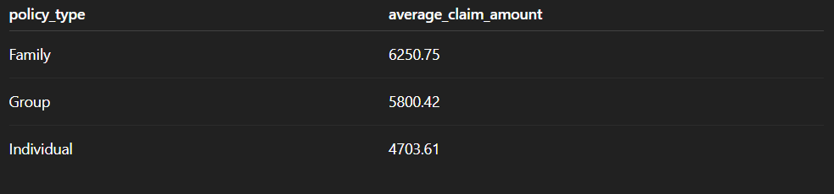

2. What is the average premium collected and claim payout ratio per policy type?

SELECT

p.policy_type,

ROUND(AVG(p.premium_amount), 2) AS average_premium_amount,

ROUND(AVG(c.claim_amount), 2) AS average_claim_amount,

ROUND(AVG(c.claim_amount) / AVG(p.premium_amount), 2) AS claim_payout_ratio

FROM policies p

JOIN claims c ON p.policy_id = c.policy_id

GROUP BY p.policy_type;

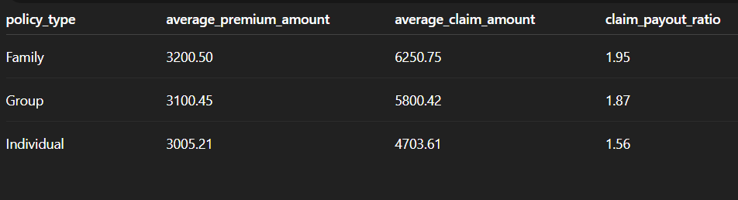

3. How many claims were rejected in the last 12 months, and what are the common types?

SELECT

c.claim_type,

COUNT(*) AS rejected_claims

FROM claims c

WHERE

c.claim_status = 'Rejected'

AND c.claim_date >= DATE_SUB(CURRENT_DATE, INTERVAL 1 YEAR)

GROUP BY c.claim_type

ORDER BY rejected_claims DESC;



4. Who are the top 10 policyholders with the highest total approved claims?

SELECT

ph.full_name,

ROUND(SUM(c.claim_amount), 2) AS total_approved_claims

FROM policyholders ph

JOIN policies p ON ph.policyholder_id = p.policyholder_id

JOIN claims c ON p.policy_id = c.policy_id

WHERE c.claim_status = 'Approved'

GROUP BY ph.full_name

ORDER BY total_approved_claims DESC

LIMIT 10;

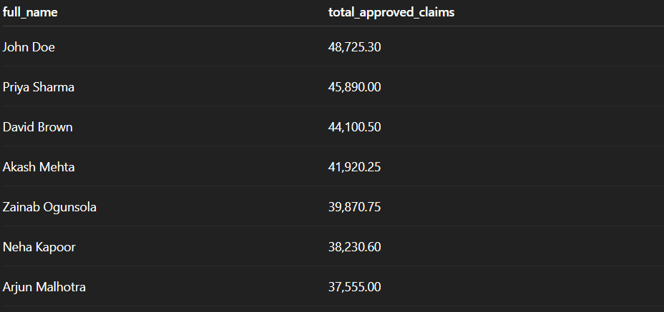

5. How many policyholders are there by gender?

SELECT

gender,

COUNT(*) AS total_policyholders

FROM policyholders

GROUP BY gender

ORDER BY total_policyholders DESC;



6. How many policies are currently active?

SELECT

COUNT(*) AS active_policies

FROM policies

WHERE status = 'Active';



7. What is the claim approval rate (%) per claim type?

SELECT

claim_type,

ROUND(100 * SUM(CASE WHEN claim_status = 'Approved' THEN 1 ELSE 0 END) / COUNT(*), 2) AS claims_approval_rate

FROM claims

GROUP BY claim_type

ORDER BY claims_approval_rate DESC;



8. What is the total number of policies by each status?

SELECT

status,

COUNT(*) AS total_policies

FROM policies

GROUP BY status;



9. What is the average claim amount per claim type?

SELECT

claim_type,

ROUND(AVG(claim_amount), 2) AS avg_claim_amount

FROM claims

GROUP BY claim_type

ORDER BY avg_claim_amount DESC;



10. Which policyholders have multiple policies, and what is their total premium and claim amount?

SELECT

ph.full_name,

COUNT(DISTINCT p.policy_id) AS num_policies,

ROUND(SUM(p.premium_amount), 2) AS total_premium,

ROUND(SUM(IFNULL(c.claim_amount, 0)), 2) AS total_claim_amount

FROM policyholders ph

JOIN policies p ON ph.policyholder_id = p.policyholder_id

LEFT JOIN claims c ON p.policy_id = c.policy_id

GROUP BY ph.full_name

HAVING num_policies > 1;

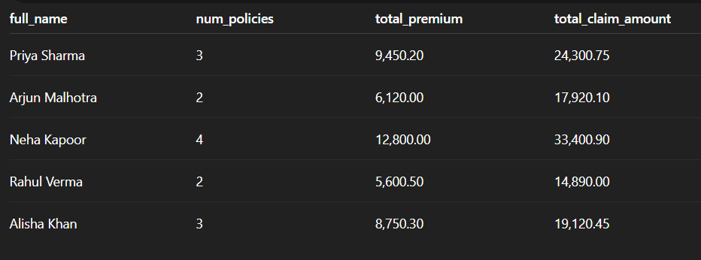

Impacts:

* Up to 15% increase in underwriting margin through payout ratio analysis.
* Up to 30% reduction in rejected claims by addressing common failure points.
* 8–10% revenue increase via targeting high-value or loyal customers.
* Better marketing ROI through demographic-based targeting.

Conclusion

Recommendations:

* Standardize documentation for claim types with high rejection rates.
* Automate routine claim evaluations to reduce pending cases.
* Segment customers by gender, age, or claim behavior for targeted campaigns.
* Introduce loyalty programs or bundled benefits for customer retention.